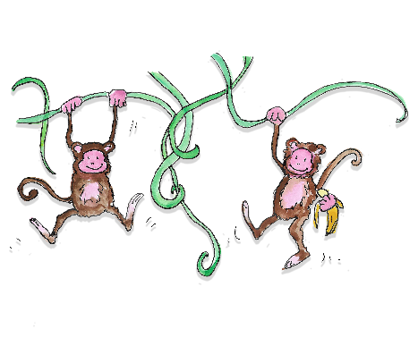 | Queensferry Parish Church  Jungle Adventure Family Worship

Sunday 15th August 2021 from 4pm
at Newgardens, Dalmeny

Please complete one form for each family and return to: childrenyouth@qpcweb.org

Names of family members who will be coming:

Parents/other adults:
First name and surname
1.
2.
3.

Children:
First name | Age
1.
2.
3.
4.

Email address: Phone/Mobile:

Any other info (e.g. allergies, medical issues or additional support needs) that we should know:

I give permission for the details on this form to be stored and used by the church, and for NHS Test & Protect requirements if applicable YES / NO
I give permission for me and members of my family to be included in photos/video taken during the event YES / NO
(Photos/video may be used for church purposes, including publicity and social media. If you would prefer your family not to be included, we will gladly do our best to respect that, but – as this is a public event – we cannot prevent other people from taking photos etc.)

Confirmation by parent/carer: Date:
--------------------------------------------------------------------------------------------------------------------------
Thankyou for submitting this form. We will email you nearer the time with further information.
Meanwhile – if you have any questions, please contact Jill jill@qpcweb.org

Queensferry Parish Church of Scotland – registered Scottish charity SC002329

